CLOUD COMPUTING
LAB 10



Submitted To:
Engr. Shoaib

Submitted By:
Komal Kashif
BSE V-A
2023-BSE-031

Task 1 — GitHub CLI, Codespace setup and authentication
(Local desktop) Install GitHub CLI: winget install --id GitHub.cli
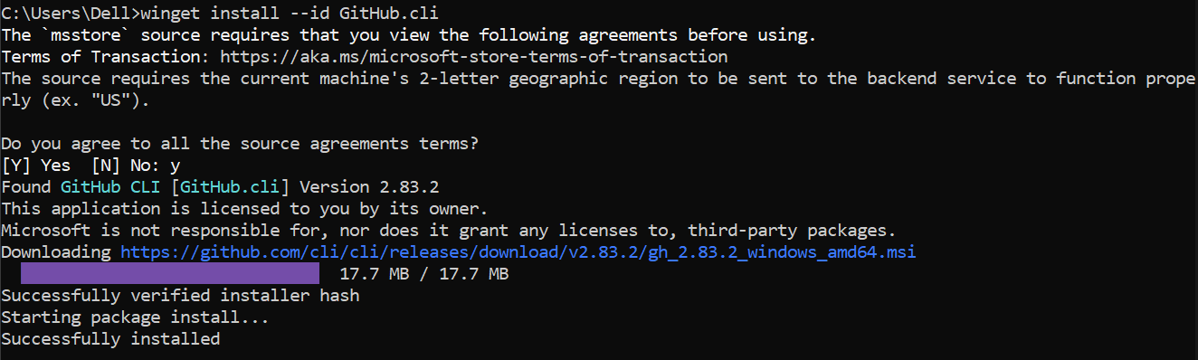
Authenticate GH CLI for Codespaces: gh auth login -s codespace
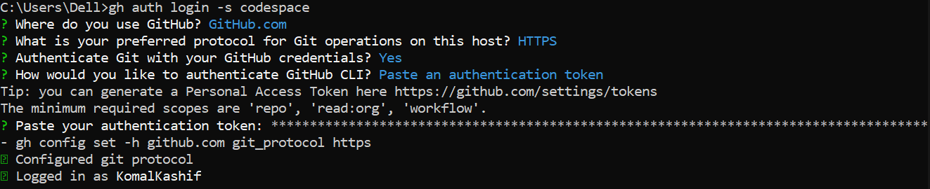
List available Codespaces: gh codespace list
Task 2 — Install AWS CLI, Terraform CLI, Provider Setup
A. Install AWS CLI
Download and install AWS CLI:
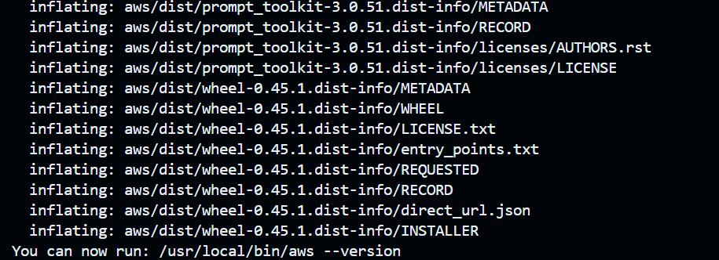

Verify credentials/config files:
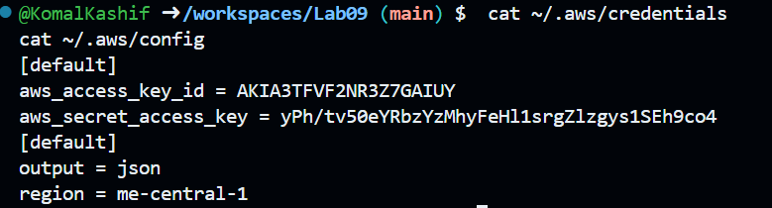
Verify connectivity
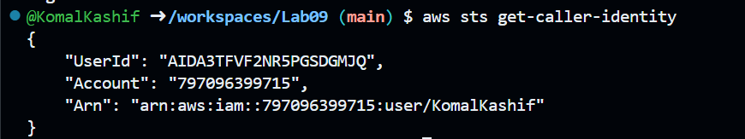
B. Install Terraform CLI
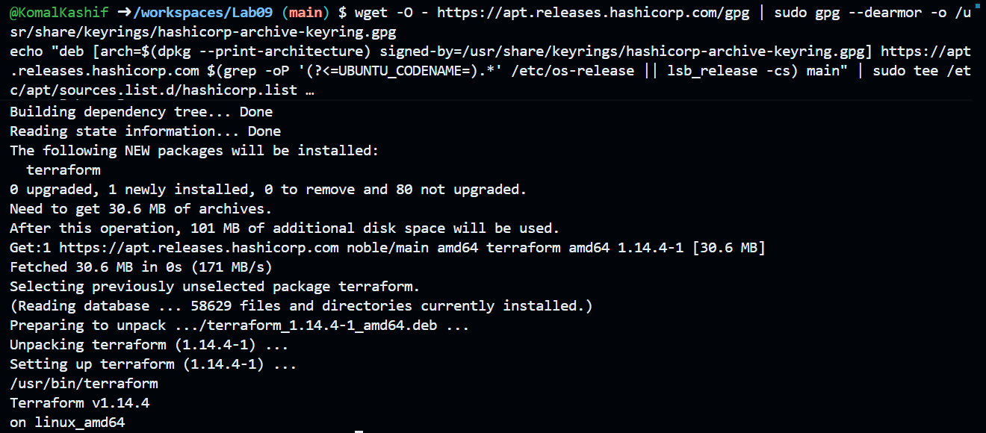
C. Provider Configuration (main.tf)
task2_terraform_install_and_version.png
task2_provider_file_creation.png
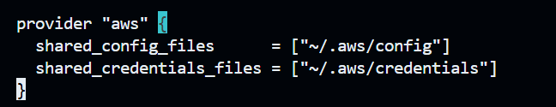

task2_terraform_init_output.png
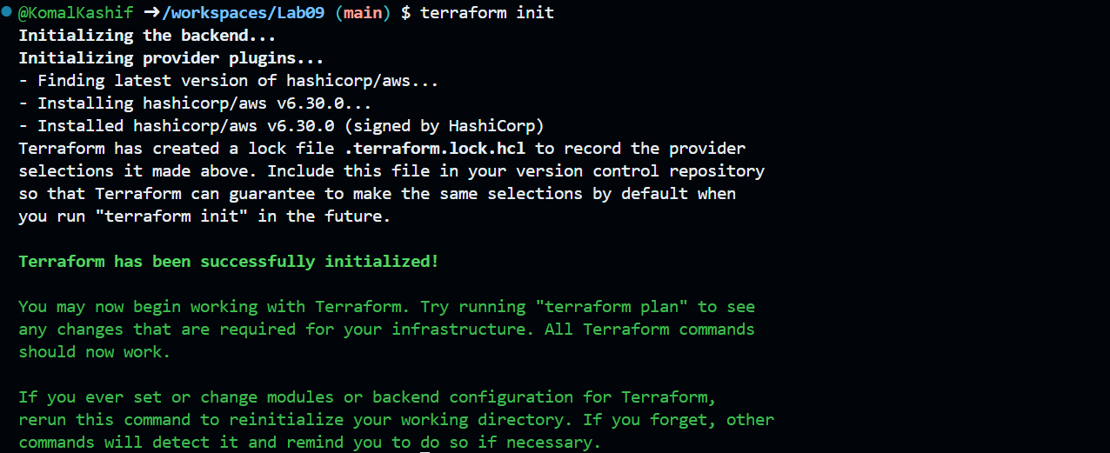
task2_terraform_lock_hcl.png
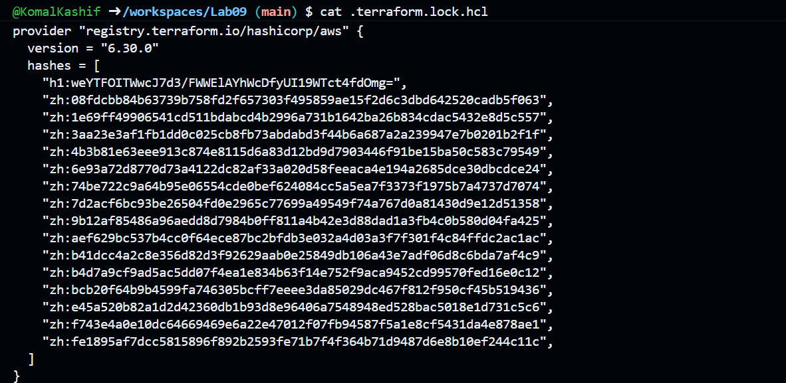
task2_terraform_dir_ls.png
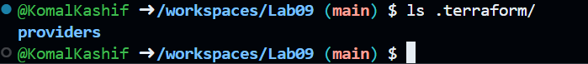

Task 3 — VPC/Subnet Creation, Initialization, Verification
task3_main_tf_resource_add.png
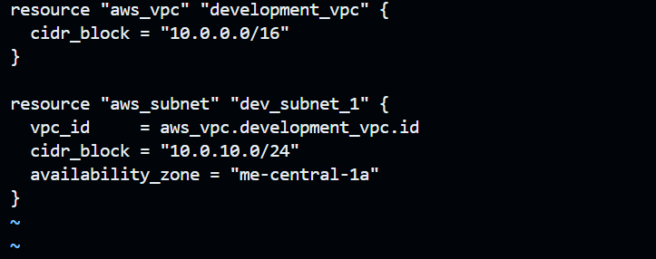
task3_terraform_apply_vpc_subnet.png
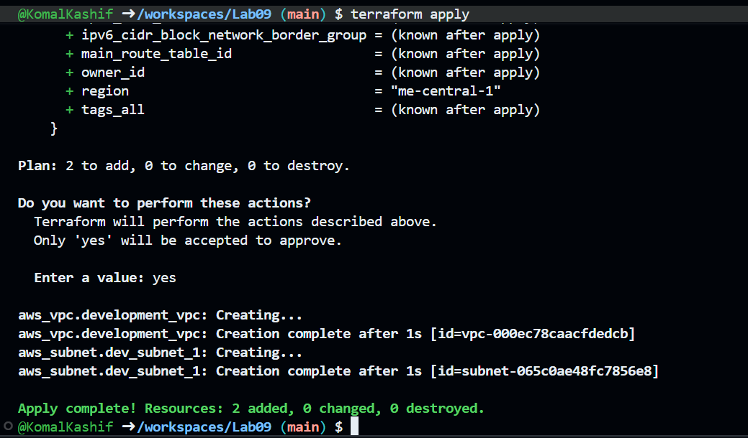
task3_aws_cli_verify_subnet.png
task3_aws_cli_verify_vpc.png

Task 4 — Data Source, Targeted Destroy, Tags
A. Data Source & Resource Creation
task4_main_tf_datasource_resource_add.png
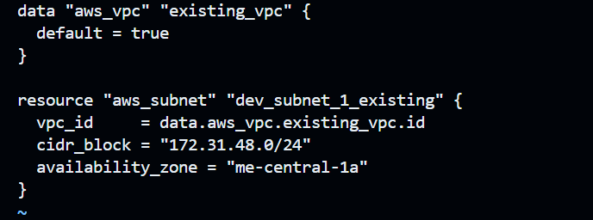
task4_terraform_apply_datasource_resource.png
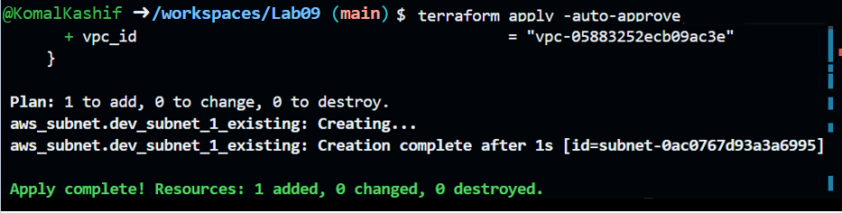
B. Targeted Destroy & Refresh
task4_terraform_destroy_targeted.png
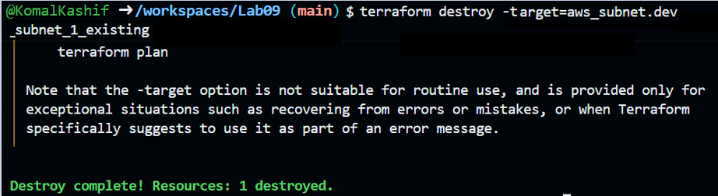
task4_terraform_refresh_state.png
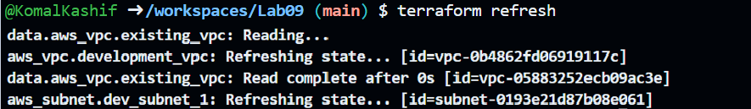
task4_terraform_apply_after_refresh
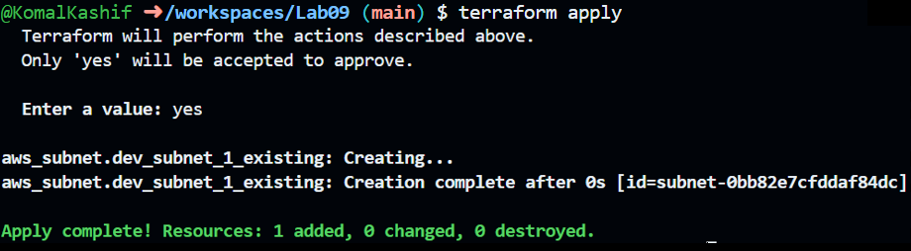
task4_terraform_destroy_all
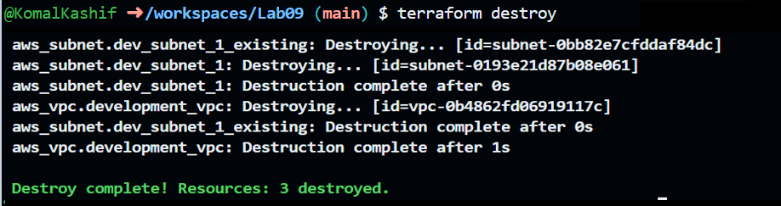
task4_terraform_plan_output.png
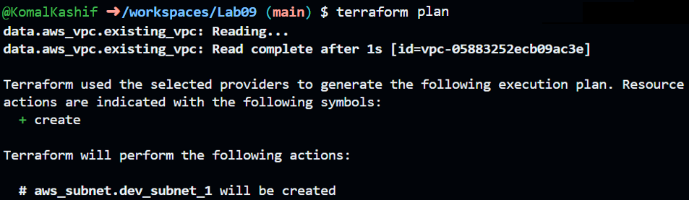

task4_terraform_apply_after_destroy.png
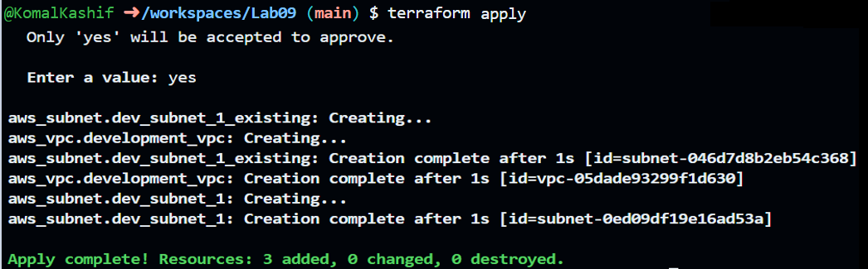
Task 5 — State File Inspection & Terraform State Commands
task5_terraform_destroy.png
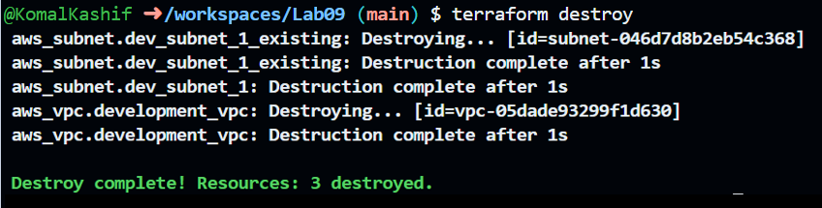
task5_terraform_state_file_empty
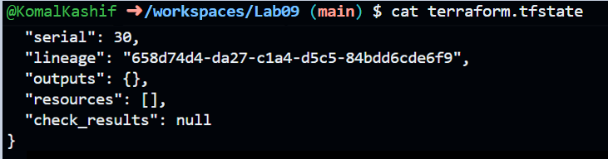
task5_terraform_state_backup_prev.png
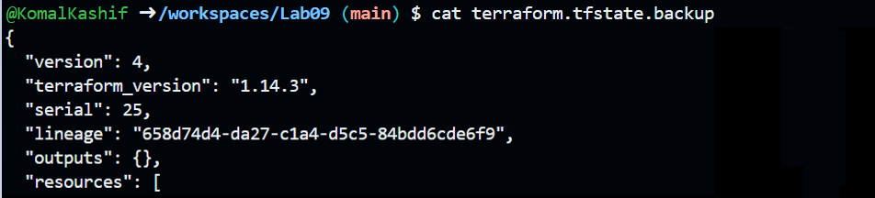
task5_terraform_apply_recreated.png
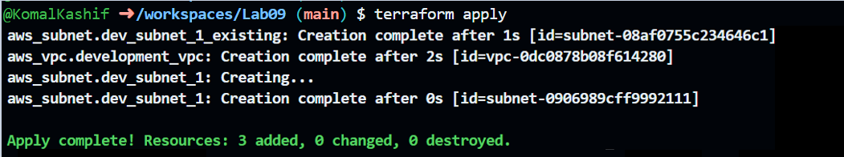

task5_terraform_state_file_populated.png
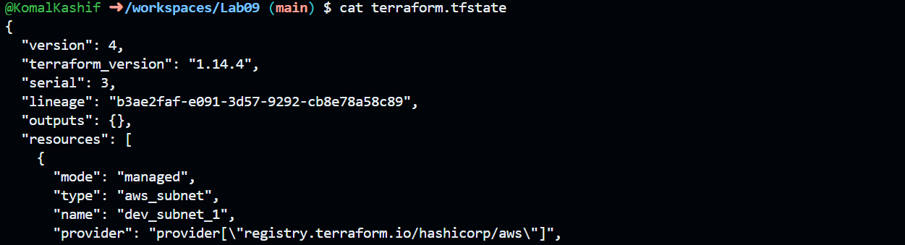
task5_terraform_state_list.png
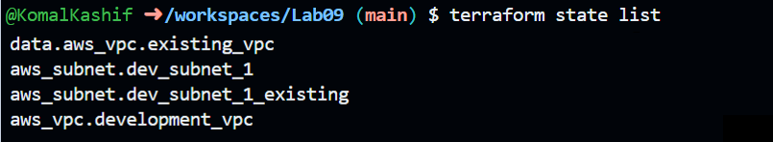
Task 6 — Terraform Outputs & Attributes Reporting
task6_terraform_outputs_basic.png
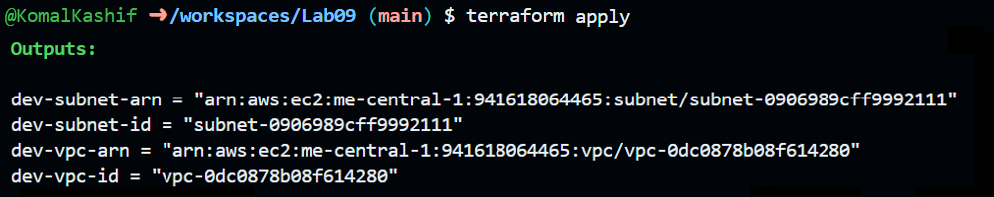
Clean up:
cleanup_destroy_resources.png
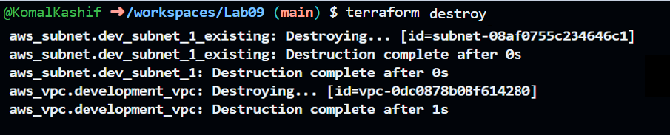
cleanup_state_files.png
